A
PROJECT REPORT
ON
“Customer Satisfaction For Restaurants Based On The Parameters For The Business Development And Revenue”
UNDER THE GUIDANCE OF
Mrs UMA. M M.Tech
(Asst. Prof (Sr.G))
MOHIT RATNESH
1201310056
SOURABH AGARWAL
1201310057

SE1050-MAJOR PROJECT
Department of Software Engineering

Final Year

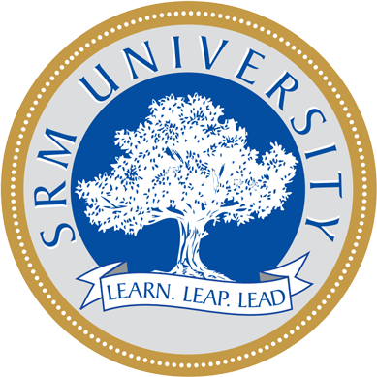

SRM UNIVERSITY

CERTIFICATE

This is to certify that Achin Kumar trainee Department of Information Technology have submitted their project report on “IT ASSET MANAGEMENT” under our supervision and guidance during the summer training session 2015. The project has been completed satisfactorily towards the partial fulfilment for the degree of Bachelor of Engineering by training under J.U.S.C.O. organisation.

J.U.S.C.O
Project Guide
Mr. Arun Kr. Mishra
Senior Manager
Department of Information Technology

ACKNOWLEDGEMENT

The successful completion of the seminar is a result of the invaluable help and guidance we received from project guide Mr. Arun Kr. Mishra
We express our gratitude towards him, as his presence has been a source of inspiration for us and has helped us become more knowledgeable in the respective field.
We are deeply indebted to the Head of Training Department Mr.D.K.Singh for his constant encouragement and moral support without which our project would not have been completed.
Last but not least we take this opportunity to thank all those who have contributed directly or indirectly through suggestions, thoughts and presence during the work of project.

Sourabh Agarwal

ABSTRACT

The act of gathering financial, contractual and inventory functions to support life cycle management and strategic decision making for the IT environment is an essential aspect in any business area. It is important for an organisation to manage their systems effectively in order to save time and money by avoiding unnecessary investments and similar incremental risks which is nothing but IT Asset Management. This project meets the primary point of accountability for the management of information technology assets in compliance with the organizational objectives. In particular, an application has been built to gather detailed hardware and software inventory information which is then used to make decisions about the purchase and redistribution of the same.

INDEX

SR. NO. | CONTENTS | PAGE NO.
1 | JUSCO ORGANIZATION | 1
2 | INTRODUCTION | 3
3 | OBJECTIVES | 5
4 | LITERATURE REVIEW | 7
5 | METHODLOGY | 8
6 | SOFTWARE AND HARDWARE REQUIREMENTS | 18
7 | MODULE DESIGN | 20
8 | CODING | 23
9 | SNAPSHOTS | 27
10 | APPLICATIONS | 29
11 | ADVANTAGES & DISADVANTAGES | 30
12 | CONCLUSION | 31
13 | FUTURE SCOPE | 32
14 | REFERENCES | 33

LIST OF FIGURES

SR. NO. | NAME | PAGE NO.
1. | Complete IT Asset Management Lifecycle with Functions and Activities | 4
2. | A minimalistic view of best practices processed under asset management. | 8
3. | Asset Register Coding | 10
4. | Old Asset Coding | 10
5. | Login Services Coding | 11
6. | Application Context Coding | 11
7. | Class Diagram of Asset Management System | 20
8. | Class Diagram of Asset Register | 20
9 | Class Diagram of Request Form | 21
10 | Collaboration Diagram of Asset Register Process | 21
11 | Collaboration Diagram of Asset Request Procedure | 22
12 | Login Page for Administrator | 27
13 | Asset Registration Form for the Administrator | 27
14 | Old Asset Request Form for the User | 28
15 | New Asset Request Form for the User | 28

LIST OF TABLES

SR. NO. | NAME | PAGE NO.
1. | Examples of Capability Gaps | 9

